**J505 Divya Dharshini Shankar**

**Banking System**

**1: Database Design:**

1.Create the database named "HMBank"

**Ans**: mysql>create database HMBank;

mysql>use HMBank;

2. Define the schema for the Customers, Accounts, and Transactions tables based on the provided schema

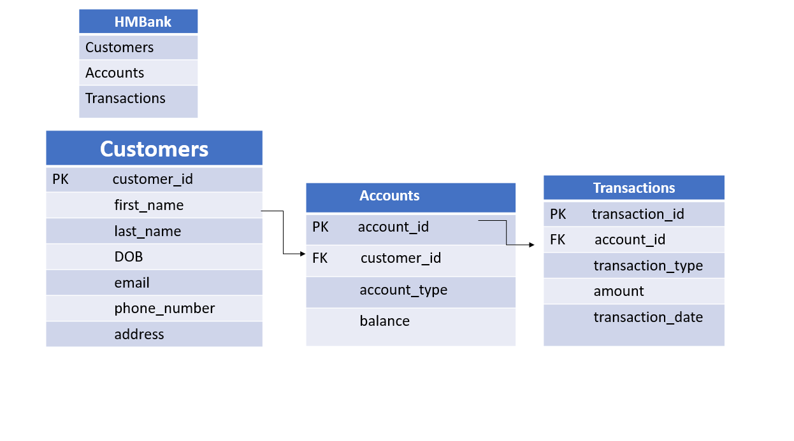**Ans:** mysql>create table Customers;

mysql>create table Accounts;

mysql>create table Transactions;

4.Create an ERD (Entity Relationship Diagram) for the database

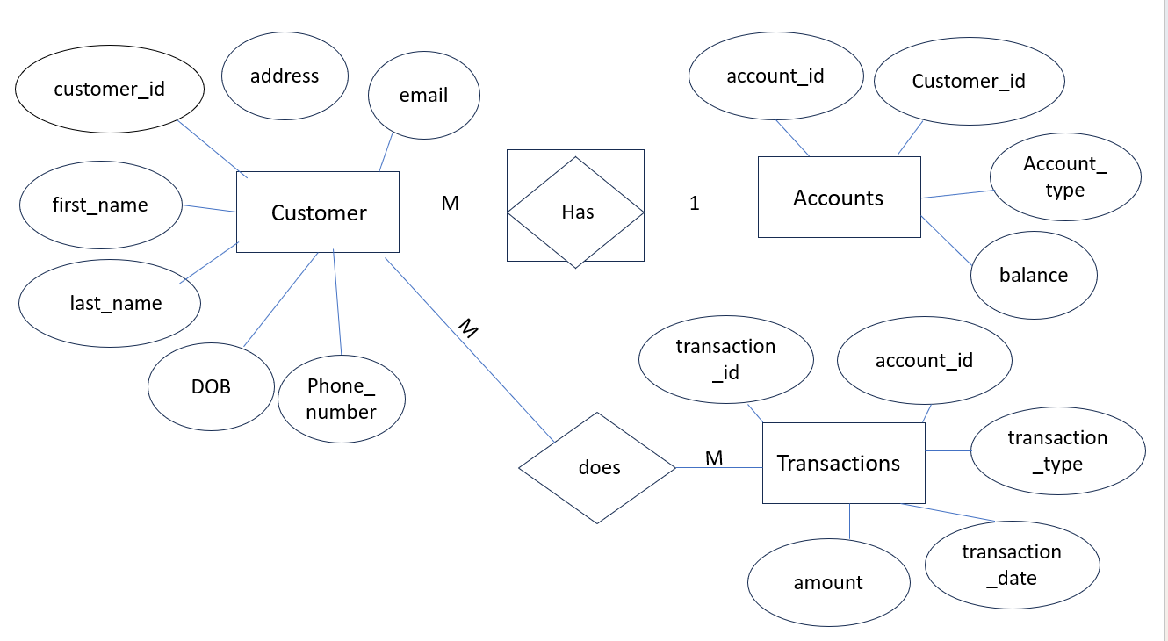

6.Write SQL scripts to create the mentioned tables with appropriate data types, constraints, and relationships.

•Customers

**Ans:**

mysql>create table customers(customer_id INT PRIMARY KEY,first_name varchar

(30) NOT NULL, last_name varchar (30) NOT NULL,DOB DATE,email varchar(30),phon

e_number int, address varchar(50));

•Accounts

**Ans:**

mysql> CREATE TABLE Accounts (

-> account_id INT PRIMARY KEY,

-> customer_id INT,

-> account_type VARCHAR(20),

-> balance INT,

-> FOREIGN KEY (customer_id) REFERENCES Customers(customer_id) );

•Transactions

**Ans:**

mysql> create table Transactions(transaction_id INT PRIMARY KEY,

-> account_id INT,

-> transaction_type varchar(20),

-> amount INT,

-> transaction_date DATE,

-> FOREIGN KEY (account_id) REFERENCES Accounts(account_id));

**Tasks 2: Select, Where, Between, AND, LIKE:**

1. Insert at least 10 sample records into each of the following tables.

•Customers

**Ans:**mysql> INSERT INTO Customers (customer_id, first_name, last_name, DOB, email, phone_number, address)

-> VALUES

-> (101, 'Abdul', 'Khan', '2000-06-13', 'abdul34@gmail.com', 6778899075, 'Chennai'),

-> (102, 'Badri', 'Kumar', '2001-04-03', 'badri6734@gmail.com', 6569169907, 'Lucknow'),

-> (103, 'Charu', 'Reddy', '1999-01-31', 'charu014@gmail.com', 9369169497, 'Andhra Pradesh'),

-> (104, 'Divya', 'Mahesh', '1998-09-17', 'divya187@gmail.com', 6569169907, 'Pune'),

-> (105, 'Eshwar', 'Pandey', '2001-08-10', 'eswari905@gmail.com', 6569169907, 'Mumbai'),

-> (106, 'Harini', 'Pandey', '2002-05-03', 'harini905@gmail.com', 6569169907, 'Salem'),

-> (107, 'Priya', 'Mithun', '2001-11-30', 'priya905@gmail.com', 6569169907, 'Bihar'),

-> (108, 'Vinay', 'Roy', '2002-12-05', 'vinay905@gmail.com', 6569169907, 'Pune'),

-> (109, 'Lokesh', 'Varma', '1995-08-29', 'lokesh905@gmail.com', 6569169907, 'Kolkata'),

-> (110, 'Komal', 'pandit', '2003-06-17', 'komal905@gmail.com', 6569169907, 'Chennai');

•Accounts

**Ans:**mysql> INSERT INTO Accounts (account_id,customer_id,account_type,balance)

-> VALUES (786,101,"savings",8000),

-> (609,102,"current",70000),

-> (123,103,"savings",9000),

-> (564,104,"zero_balance",0),

-> (409,105,"current",10000),

-> (904,106,"savings",3689),

-> (870,107,"current",7800),

-> (279,108,"savings",4560),

-> (322,109,"zero_balance",0),

-> (455,110,"current",50000);

•Transactions

**Ans:**mysql> INSERT INTO Transactions (transaction_id, account_id, transaction_type, amount, transaction_date)

-> VALUES (489, 123, 'deposit', 6700, '2023-09-30'),

-> (490, 279, 'withdrawal', 4500, '2023-09-25'),

-> (491, 322, 'deposit', 12000, '2023-08-20'),

-> (492, 409, 'transfer', 8000, '2023-07-15'),

-> (493, 455, 'deposit', 5600, '2023-06-10'),

-> (494, 564, 'withdrawal', 3000, '2023-05-28'),

-> (495, 609, 'transfer', 7200, '2023-04-17'),

-> (496, 786, 'deposit', 15000, '2023-03-05'),

-> (497, 870, 'withdrawal', 2500, '2023-02-22'),

-> (498, 904, 'transfer', 9000, '2023-01-12');

**2. Write SQL queries for the following tasks:**

1. Write a SQL query to retrieve the name, account type and email of all customers.

**Ans:**mysql> select concat(c.first_name,' ',c.last_name) AS Name ,

-> c.email ,a.account_type from customers c

-> join accounts a on c.customer_id = a.customer_id;

2. Write a SQL query to list all transaction corresponding customer.

**Ans:** mysql> select concat(c.first_name,' ',c.last_name) AS Name, t.transaction_id,

-> t. account_id,t.transaction_type,t.amount,t.transaction_date from

-> customers c join accounts a on c.customer_id = a.customer_id

-> join transactions t on a.account_id = t.account_id;

3. Write a SQL query to increase the balance of a specific account by a certain amount.

**Ans:** mysql> SELECT account_id, balance, balance + 5000 AS "new balance"

FROM Accounts WHERE account_id = 564;

4. Write a SQL query to Combine first and last names of customers as a full_name.

**Ans:** mysql>select concat(first_name,' ',last_name) As full_name from customers;

5. Write a SQL query to remove accounts with a balance of zero where the account type is savings.

**Ans:** mysql> delete from accounts where balance = 0 and account_type = 'savings';

6. Write a SQL query to Find customers living in a specific city.

**Ans:** mysql> select concat(first_name,' ',last_name) AS Name from customers

-> where address = 'pune';

7. Write a SQL query to Get the account balance for a specific account

**Ans:** mysql> select balance from accounts where account_id = 409;

8. Write a SQL query to List all current accounts with a balance greater than $1,000.

**Ans:** mysql> select * from accounts where account_type='current' and

-> balance >1000;

9. Write a SQL query to Retrieve all transactions for a specific account.

**Ans:** mysql> select * from transactions where account_id=609;

10. Write a SQL query to Calculate the interest accrued on savings accounts based on a given interest rate.

**Ans:**select account_id, balance, balance * 0.05 as interest_accrued from accounts where account_type = 'savings';

11. Write a SQL query to Identify accounts where the balance is less than a specified overdraft limit.

**Ans:** mysql> select * from accounts where balance < 5000;

12. Write a SQL query to Find customers not living in a specific city.

**Ans:** mysql> select concat(first_name,' ',last_name) AS full_name

-> from customers where address not in ('chennai');

**Tasks 3: Aggregate functions, Having, Order By, GroupBy and Joins:**

1. Write a SQL query to Find the average account balance for all customers.

**Ans**: mysql> select customer_id,avg(balance) from accounts group by customer_id;

2. Write a SQL query to Retrieve the top 10 highest account balances.

**Ans:** mysql>select balance from accounts

-> order by balance DESC;

3. Write a SQL query to Calculate Total Deposits for All Customers in specific date.

**Ans:** mysql> select sum(amount) from transactions where

-> transaction_type='deposit' and transaction_date ='2023-06-10';

4. Write a SQL query to Find the Oldest and Newest Customers

**Ans:** mysql> SELECT CONCAT(first_name, ' ', last_name) AS full_name,DOB,

-> timestampdiff(year, dob, curdate()) as age

-> from customerswhere dob = (select min(dob) from customers)

-> or dob = (select max(dob) from customers);

5.Write a SQL query to Retrieve transaction details along with the account type.

**Ans:**mysql> select t.transaction_id,t.account_id, t.transaction_type,

->t.amount,t.transaction_date, a.account_type

->from transactions t join accounts a on

->a.account_id = t.account_id;

6. Write a SQL query to Get a list of customers along with their account details.

**Ans:**mysql> select c.first_name,c.last_name,a.account_id,

-> a.customer_id,a.account_type,a.balance from customers c

-> join accounts a on c.customer_id = a.customer_id;

7. Write a SQL query to Retrieve transaction details along with customer information for a specific account

**Ans:**mysql>select concat(c.first_name,c.last_name) AS full_name,c.DOB,c.email,c.phone_number, c.address,c.customer_id, t.transaction_id,t.account_id, t.transaction_type,t.amount,t.transaction_date from customers c join accounts a on c.customer_id = a.customer_id join transactions t on a.account_id = t.account_id where a.account_id=904;

8. Write a SQL query to Identify customers who have more than one account. ;

**Ans:**mysql> select c.first_name,c.last_name,c.customer_id

from customers c join accounts a on c.customer_id = a.customer_id

group by c.customer_id having count(a.account_id) > 1 ;

9. Write a SQL query to Calculate the difference in transaction amounts between deposits and withdrawals.

**Ans:** mysql> select t.account_id,t.amount as deposit_amount,t1.amount as withdrawal_amount,

(t.amount-t1.amount) as transaction_amounts

from transactions t join transactions t1 on

t.account_id=t1.account_id

where t.transaction_type ='deposit' and t1.transaction_type='withdrawal';

10. Write a SQL query to Calculate the average daily balance for each account over a specified period.

Ans:mysql>select t.account_id ,avg(a.balance) from accounts a join

transactions t on a.account_id = t.account_id where DATE(t.transaction_date)=current_date()

group by t.account_id;

11. Calculate the total balance for each account type.

**Ans:**mysql> select sum(balance) as Total_balance from accounts

-> group by account_type;

12. Identify accounts with the highest number of transactions order by descending order.

**Ans:**mysql> select account_id, count(*) as total_transactions from transactions

-> group by account_id order by total_transactions desc;

13. List customers with high aggregate account balances, along with their account types.

**Ans:**mysql> select concat(c.first_name,' ',c.last_name) as full_name,

-> a.account_type,a.balance from customers c join accounts a on

-> c.customer_id = a.customer_id

-> having balance>5000 order by a.balance desc;

14. Identify and list duplicate transactions based on transaction amount, date, and account.

**Ans:**mysql> select t.* ,t1.* from transactions t join transactions t1

-> on t.account_id = t1.account_id

-> where (t.amount!=t1.amount or

-> t.transaction_date != t1.transaction_date ) and

-> t.transaction_id != t1.transaction_id;

**Tasks 4: Subquery and its type:**

1. Retrieve the customer(s) with the highest account balance.

**Ans:** mysql>select c.* from customers c join

->(select customer_id, max(balance) as max_balance from accounts

-> group by customer_id) a on c.customer_id = a.customer_id

-> order by a.max_balance desc limit 1;

2. Calculate the average account balance for customers who have more than one account.

**Ans:** mysql>select (a.balance) as avg_balance from accounts a

-> join (select customer_id from accounts group by customer_id

-> having count(account_id)>1) a1 on a.customer_id != a1.customer_id;

3. Retrieve accounts with transactions whose amounts exceed the average transaction amount.   
**Ans:**mysql> select account_id ,amount from transactions where amount >

-> ( select avg(amount) as avg_amount from transactions);

4. Identify customers who have no recorded transactions.

**Ans:** mysql>select customer_id from customers where customer_id not in

(select distinct customer_id from accounts join transactions

on accounts.account_id = transactions.account_id );

5. Calculate the total balance of accounts with no recorded transactions.

**Ans:** mysql>select c.customer_id ,(select sum(a.balance) from accounts a

where a.customer_id = c.customer_id) as total_balance from customers c where c.customer_id not in ( select distinct a.customer_id from accounts a

join transactions t on a.account_id = t.account_id );

6. Retrieve transactions for accounts with the lowest balance.

**Ans:** mysql>select t.*,a.account_id,a.balance from transactions t join

(select account_id,balance from accounts where balance =(select min(balance) from accounts ) ) a on a.account_id = t.account_id;

7. Identify customers who have accounts of multiple types.

**Ans**: mysql> select customer_id from accounts where customer_id in

-> (select customer_id from accounts group by customer_id

-> having count(Distinct account_type)>1);

8. Calculate the percentage of each account type out of the total number of accounts.   
**Ans**: mysql> select account_type, count(account_id) as total_accounts,

(count(account_id) * 100.0 / (select count(*) from accounts)) as percentage

from accounts group by account_type;

9. Retrieve all transactions for a customer with a given customer_id.   
**Ans:** mysql> select a.customer_id,a.account_id,t.* from transactions t join

(select customer_id,account_id from accounts where customer_id =103)

a on a.account_id=t.account_id;

10. Calculate the total balance for each account type, including a subquery within the SELECT clause.

**Ans**:mysql>select distinct a.*, a1.total_balance from accounts a

join ( select account_type, sum(balance) as total_balance

from accounts group by account_type )

a1 on a.account_type = a1.account_type;